Chapter 2
Introduction to Probability

Case Problem: Hamilton County Judges

The data in the table provides the basis for the analysis. We provide notes as a guide to answering questions 1 through 5.

1. The conditional probabilities of cases being appealed in the three courts are given in the 3 Total rows in the table. For Common Pleas Court, the probability of an appeal is .0401; for Domestic Relations Court, the probability of an appeal is .00348; and for Municipal Court, the probability of an appeal is .00461. Appeals are much more likely in Common Pleas Court. But, even there, only 1 in 25 cases are appealed. The unconditional probability of an appeal across all 3 courts is

(1762 + 106 + 500)/(43,945 + 30,499 + 108,464) = .0129.

2. The probability of a case being appealed for each judge is given in column 5 of the table. Judges Winkler, Panioto and Grady have the lowest probability of appeal for Common Pleas, Domestic Relations and Municipal Courts respectively.

3. The probability of a case being reversed for each judge is given in column 7 of the table. Judges Winkler, Panioto and Grady/Hair have the lowest probability of reversal for Common Pleas, Domestic Relations and Municipal Courts respectively. These are the probabilities for reversal for all cases disposed of, not just the ones appealed.

4. The probability of a reversal given an appeal for each judge is given in column 9 of the table. Judges Nurre, Panioto and Grady/Hair have the lowest probability of reversal for Common Pleas, Domestic Relations and Municipal Courts respectively.

5. We describe here how The Cincinnati Enquirer used this data to rank the judges. Other approaches may also be valid, but a rationale should be provided. The newspaper provided ranking for each judge within each of the courts on percentage of cases appealed, percentage of cases reversed and percentage of appealed cases reversed. Those rankings were the same as the ones we have computed based on probabilities in columns 6, 8 and 10 of the table. Then they summed the 3 rankings to come up with a total ranking for each judge. We provide those total ranks in column 11 of the table. Judge Winkler is the highest ranked judge in Common Pleas Court, Judge Panioto is the highest ranked judge in Domestic Relations Court and Judge Grady is the highest ranked judge in Municipal Court.

Common Pleas Court
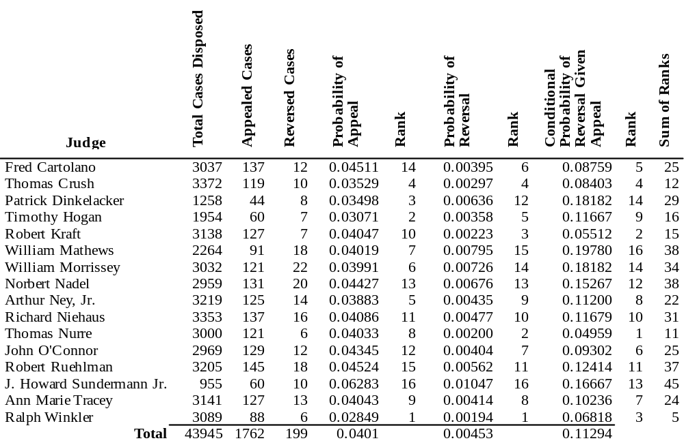

Domestic Relations Court
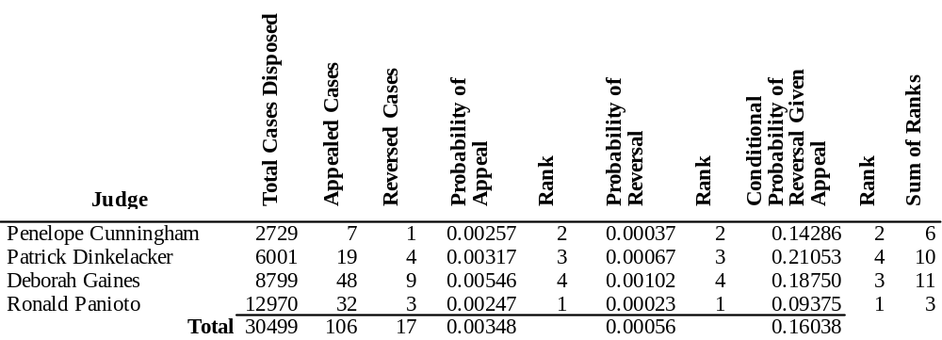

Municipal Court
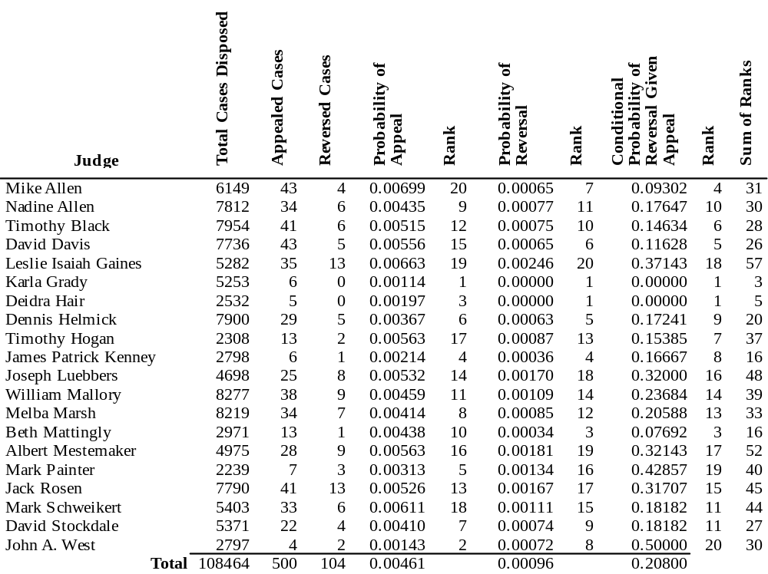
Case Problem: College Softball Recruiting

The data in the table provides the basis for the analysis. We provide notes as a guide to answering questions 1 through 4.

 | Junior Year |  | Senior Year
 | At Bats | Hits | At Bats | Hits
Fran Hayes | 200 | 70 | 40 | 15
Millie Marshall | 196 | 67 | 205 | 76

1. Calculate the batting average of each player for her junior year, then also calculate the batting average of each player for her senior year. Which player would this analysis lead you to choose?

 | Junior Year |  |  | Senior Year
 | At Bats | Hits | Batting Average | At Bats | Hits | Batting Average
Fran Hayes | 200 | 70 | 0.350 | 40 | 15 | 0.375
Millie Marshall | 196 | 67 | 0.342 | 205 | 76 | 0.371

Fran Hayes had a higher batting average than Millie Marshall during their junior year and during their senior year. This analysis suggests the university should offer Fran the scholarship.

2. Calculate the batting average of each player for her combined junior and senior years. Which player would this analysis lead you to choose?

Combined Junior
& Senior Years
 | At Bats | Hits | Batting Average
Fran Hayes | 240 | 85 | 0.354
Millie Marshall | 404 | 143 | 0.357

When each player’s junior and senior years are combined, Millie Marshall has a higher batting average than Fran Hayes. This analysis suggests the university should offer Millie the scholarship.

3. After considering both of your analyses, which player would you choose? Why?

Although Fran Hayes' batting average exceeds Millie Marshall’s batting average during both their junior and their senior years, Fran achieved her advantage during their senior year over substantially fewer at bats (40 for Fran and 205 for Millie). Millie has actually proven herself over two full seasons and should be selected over Fran.

4. Prepare a report on your findings for the athletic director and coach of the college program. Focus on clearly explaining the discrepancy in your two analyses.

In addition to explaining your responses to the previous questions, your report should explain how this seemingly paradoxical result has occurred. You could start by explaining that during their junior year, Millie Marshall had a slightly lower batting average than Fran Hayes over a similar number of at bats (196 for Millie and 200 for Fran). While both Fran and Millie improved their batting averages during their senior years, Millie's improvement occurred over a far greater number of at bats (205 for Millie and 40 for Fran). Thus, even though Millie's batting average was again slightly lower than Fran's batting average during their senior year, Millie's senior year performance resulted in a greater overall improvement when combined with her junior year statistics.

